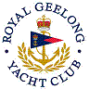 | Royal Geelong Yacht Club Inc.  Est 1859
Trophy Deed of Gift.

Trophy: | Sea Wren Perpetual Trophy
Presented by: | Rupert H. Meakin
Date: | 1930
For: | Winner Division II Aggregate
Remarks / Revisions
Click here for a List of Recipients

